Acronyms and Glossary

ACI Application Container Image

AESD Advanced Energy System Design

API application programming interface

C++ a programming language

CSV comma-separated-value file

Chrome a web browser

Firefox a web browser

Google Protocol Buffers a serialization specification

HTTP Hypertext Transfer Protocol

HTTPS Hypertext Transfer Protocol Secure

Haskell a programming language

IoT Internet of Thinks

JSON JavaScript Object Notation

JavaScript a programming language

MySQL a database server product

NREL National Renewable Energy Laboratory

ODBC Open Database Connectivity

POSIX Epoch seconds since midnight 1 January 1970 UTC

PostgreSQL a database server product

Project Haystack a specification for data feeds from the Internet of Thinks (IoT)

Python a programming language

R a programming language

REST representational state transfer

Rkt a container engine (CoreOS 2017b)

SQLite3 a database server product

TSV tab-separate-value file

URI uniform resource identifier

UTC Coordinated Universal Time

WebSockets a communication protocol

YAML YAML Ain’t Markup Language

Abstract

The Records API (application program interface) for Advanced Energy System Design (AESD) enables software that serves multidimensional record-oriented data to interoperate with software that uses such data. In the context of the Records API, multidimensional data records are simply tuples of real numbers, integers, and character strings, where each data value is tagged by a variable name, according to a pre-defined schema, and each record is assigned a unique integer identifier. Conceptually, these records are isomorphic to rows in a relational database, JSON objects, or key-value maps. Records servers might supply static data sets, sensor measurements that periodically update as new telemetry become available, or the results of simulations as the simulations generate new output. Records client software might display or analyze the data, but in the case of simulations, the client requests the creation of new ensembles for specified input parameters. It is also possible to chain records clients and servers together so that a client consuming data from a server might transform that data and serve it to additional clients.

This minimalist API avoids imposing burdensome metadata, or structural or implementation requirements on developers by relying on open source technologies that are readily available for common programming languages. In particular, the API has been designed to place the least possible burden on services that provide data. This document defines the message format for the Records API, a transport mechanism for communicating the data, and the semantics for interpreting it. The message format is specified as Google Protocol Buffers (Google Developers 2017b) and the transport mechanism uses WebSockets (Internet Engineering Task Force 2017). We discuss five major use cases for serving and consuming records data: (1) static data, (2) dynamically augmented data, (3) on-demand simulations, (4) with filters, and (5) with bookmarks. Separate implementations of the API exist in C++, Haskell, JavaScript, Python, and R.

Table of Contents

Overview 5

Use Cases 7

Static Data 7

Dynamic Data 12

Simulations 13

Bookmarks 14

Filtering 16

Records API, Version 4 17

Message Groups 17

General Conventions 19

Messages 19

Scalar Value Types 30

Implementations 32

Haskell Client and Server Library and Applications 33

C++ Server and Client 37

JavaScript Client Library and Web-Based Browser 37

Python Client Library 39

Appendix 43

Protocol Buffers for Records API Version 4 43

References 48

List of Figures

Containment relationships between protocol buffer messages in the Records API 6

Visualizing data from a static source using the Records API 8

Visualizing data from a dynamic source using the Records API 12

Steering and visualizing simulation results using the Records API 13

Creating and retrieving a bookmark and its associated data 14

User interface for the Records API browser 38

Example of a Python session using the Records API 42

List of Tables

Correlation between Requests and Responses 5

Available Client and Server Applications and Libraries for the Records API 32

Command-Line Arguments for Serving TSV Files 35

Parameters for Database Back Ends Serving the Records API 35

Command-Line Arguments for Serving Haystack Data Feeds 36

YAML Configuration Parameters for Haystack-Based Records API Servers 37

Overview

Client-server communication in the Records API simply consists of clients sending Request messages to the server and servers asynchronously sending Response messages to the client. The request and response messages hold the specifics of the request or response and the responses are correlated with the requests; however, it is important to note that multiple responses may occur for a single request, as when record data are chunked into multiple response, or that an error response may be sent at any time. The nested messages within Request and Response may in turn contain nested fields and messages providing further details. The table below shows the correspondence between requests and responses, while the figure following that shows the containment relationships between message types.

Correlation between Requests and Responses

|  |  |
| --- | --- |
| Request Field | Response Field |
| models_metadata | models or error |
| records_data | data or error |
| bookmark_meta | bookmarks or error |
| save_bookmark | bookmarks or error |
| cancel | no response or error |
| work | data or error |

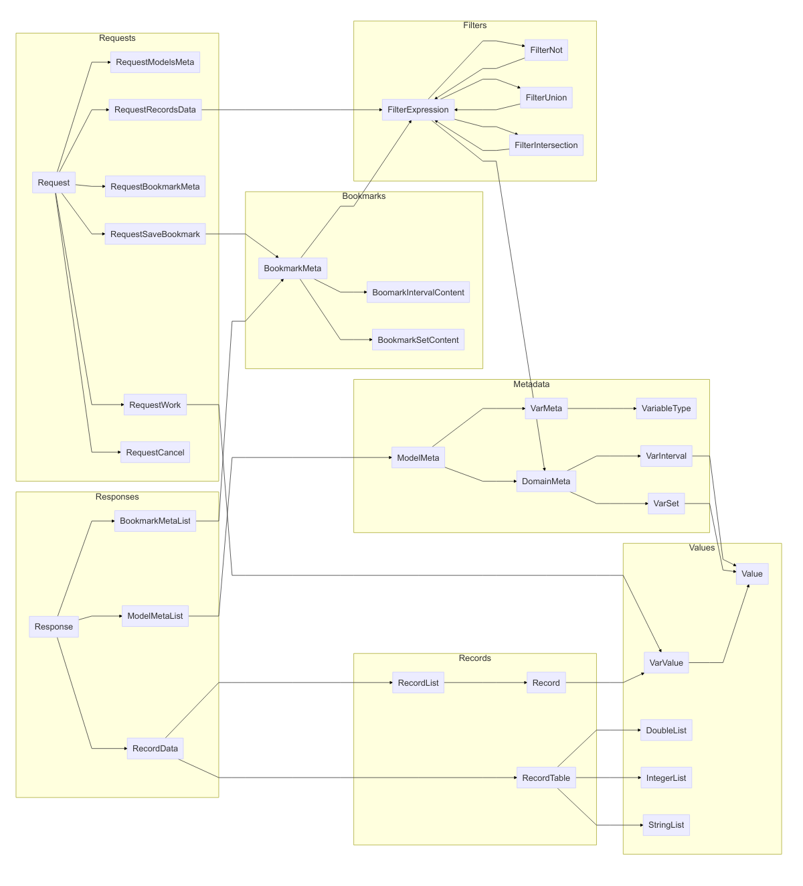

Containment relationships between protocol buffer messages in the Records API

Metadata messages describe “models,” which are just sources of data, and the variables they contain. Data record messages hold the data itself. Data records are simply tuples of real numbers, integers, and character strings, where each data value is tagged by a variable name, according to a pre-defined schema, and each record is assigned a unique integer identifier. Conceptually, these records are isomorphic to rows in a relational database, JSON objects, or key-value maps. For efficiency and compactness, RecordData may be provided in list format or tabular format, with the latter format obtained only when the contents of the table all have the same data type. The data records may be provided *in toto* or filtered using filter messages so that only certain fields or records are returned. The API contains a small embedded language for filtering via set and value operations. Sets of records may be bookmarked for sharing or later retrieval by (1) enumerating their unique record identifiers, (2) defining a range of unique record identifiers, or (3) specifying a filtering criterion.

Servers that perform computations or simulations can receive input parameters via a RequestWork message that contains those input parameters. After the server has completed its computations, it sends the results as RecordData messages.

In general, the response to a request for data records comes in *chunks* numbered in sequence, where each chunk has an identifier, chunk_id, and the response specifies the identifier of the next chunk, next_chunk_id. Thus, the chunks form a linked list. The sending of additional chunks can be cancelled using a RequestCancel message. If the subscribe flag is set when making a request, the server will respond indefinitely with additional data as it becomes available, until the subscription is cancelled.

Use Cases

In this section we outline some standard use cases for the Records API. UML Sequence Diagrams (Fowler 2017) illustrate the flow of messages and the messages themselves are printed in the text format output by the Google protoc tool (Google Developers 2017a).

Static Data

The retrieval of static data records forms the simplest use case for the Records API. A user chooses a particular data source (a “model” in the parlance of the Records API) and then the data are retrieved and displayed. The visualization client software communicates with a Records server, which in turn accesses the static data. The figure below illustrates the process.

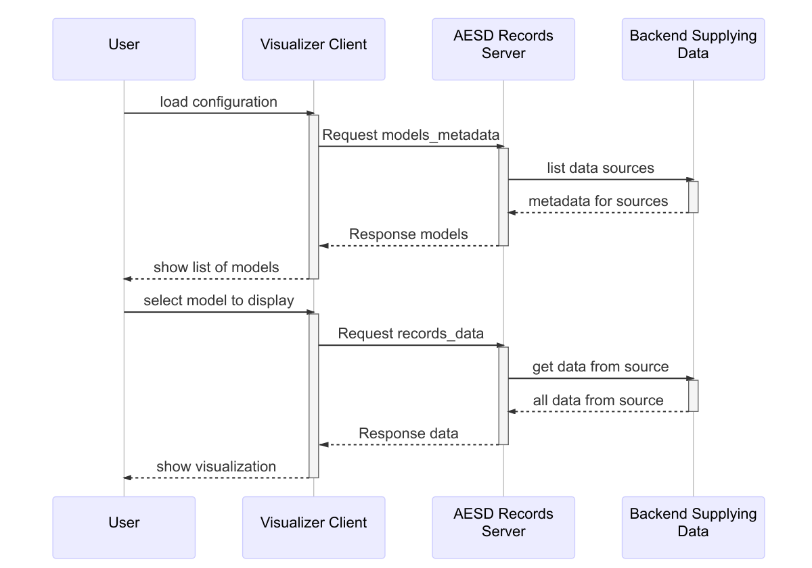

Visualizing data from a static source using the Records API

A Request without model_id specified requests the server to list all models:

version: 4  
id: 1  
models_metadata {  
}

The Response from the server provides metadata for all of the models:

version: 4  
id: 1  
models {  
 models {  
 model_id: "example-model-1"  
 model_name: "Example Model #1"  
 model_uri: "http://esda.nrel.gov/examples/model-1"  
 variables {  
 var_id: 0  
 var_name: "Example Real Variable"  
 type: REAL  
 }  
 variables {  
 var_id: 1  
 var_name: "Example Integer Variable"  
 type: INTEGER  
 }  
 variables {  
 var_id: 2  
 var_name: "Example String Variable"  
 type: STRING  
 }  
 models {  
 model_id: "example-model-2"  
 model_name: "Example Model #2"  
 model_uri: "http://esda.nrel.gov/examples/model-2"  
 variables {  
 var_id: 0  
 var_name: "POSIX Epoch"  
 type: INTEGER  
 }  
 variables {  
 var_id: 1  
 var_name: "Measurement"  
 type: REAL  
 }  
 }  
 models {  
 model_id: "example-simulation-3"  
 model_name: "Example Simulation #3"  
 model_uri: "http://esda.nrel.gov/examples/simulation-3"  
 variables {  
 var_id: 0  
 var_name: "Input"  
 type: REAL  
 }  
 variables {  
 var_id: 1  
 var_name: "Time"  
 type: REAL  
 }  
 variables {  
 var_id: 2  
 var_name: "Value"  
 type: REAL  
 }  
 inputs {  
 var_id: 0  
 interval {  
 first_value: 0  
 second_value: 100  
 }  
 }  
 }  
}

Note that the response above is tagged with the same id as the request; this allows the client to correlate responses with the particular requests it makes. Next, the user might request three records from the first model:

version: 4  
id: 2  
records_data {  
 model_id: "example-model-1"  
 max_records: 3  
}

The record data might be returned as two chunks, where the first chunk is

version: 4  
id: 2  
chunk_id: 1  
next_chunk_id: 2  
data {  
 list {  
 records {  
 record_id: 10  
 variables {  
 var_id: 0  
 value: 10.5  
 }  
 variables {  
 var_id: 1  
 value: -5  
 }  
 variables {  
 var_id: 2  
 value: "first"  
 }  
 }  
 records {  
 record_id: 20  
 variables {  
 var_id: 0  
 value: 99.2  
 }  
 variables {  
 var_id: 1  
 value: 108  
 }  
 variables {  
 var_id: 2  
 value: "second"  
 }  
 }  
 }  
}

and the last chunk is:

version: 4  
id: 2  
chunk_id: 2  
next_chunk_id: 0  
data {  
 list {  
 records {  
 record_id: 30  
 variables {  
 var_id: 0  
 value: -15.7  
 }  
 variables {  
 var_id: 1  
 value: 30  
 }  
 variables {  
 var_id: 2  
 value: "third"  
 }  
 }  
 }  
}

Dynamic Data

As shown in the following figure, retrieving data from a dynamic source proceeds quite similarly to retrieving data from a static source. The only essential difference is that the server repeatedly sends additional responses containing new data, until a request to cancel is sent.

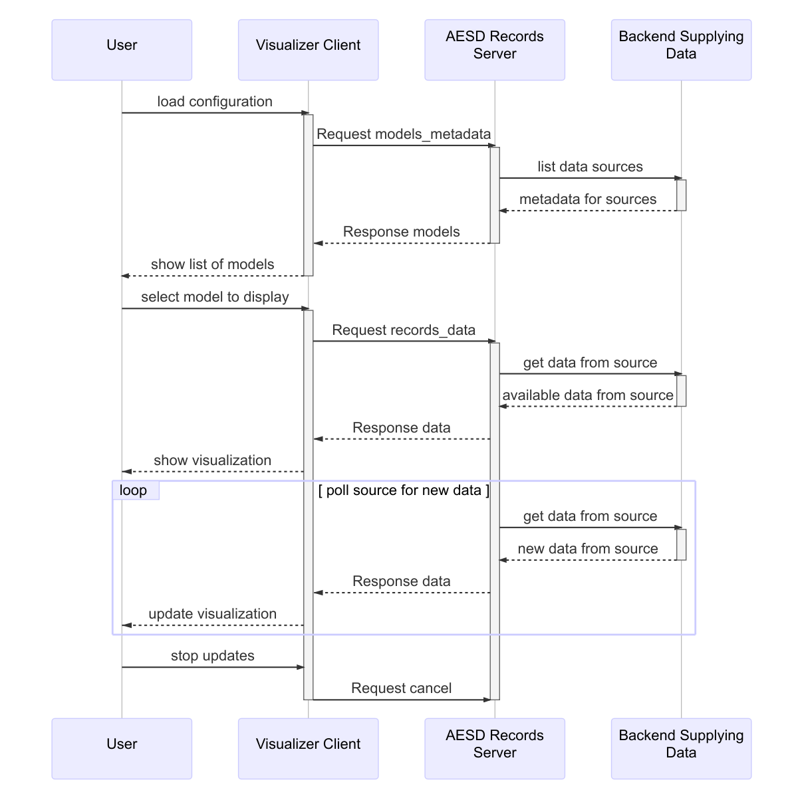

Visualizing data from a dynamic source using the Records API

When requesting dynamic data, it is advisable to set the subscribe flag in the request for data:

version: 4  
id: 2  
subscribe: true  
records_data {  
 model_id: "example-model-2"  
}

The RequestCancel message is the cancel field Request and must include the id of the request to be cancelled:

version: 4  
cancel {  
 id: 2  
}

Simulations

The model Example Simulation #3 in the Static Data use case is a simulation model, as evidenced by the presence of the inputs field in its metadata. The following figure shows a typical interaction with a simulation-based model via the Records API.

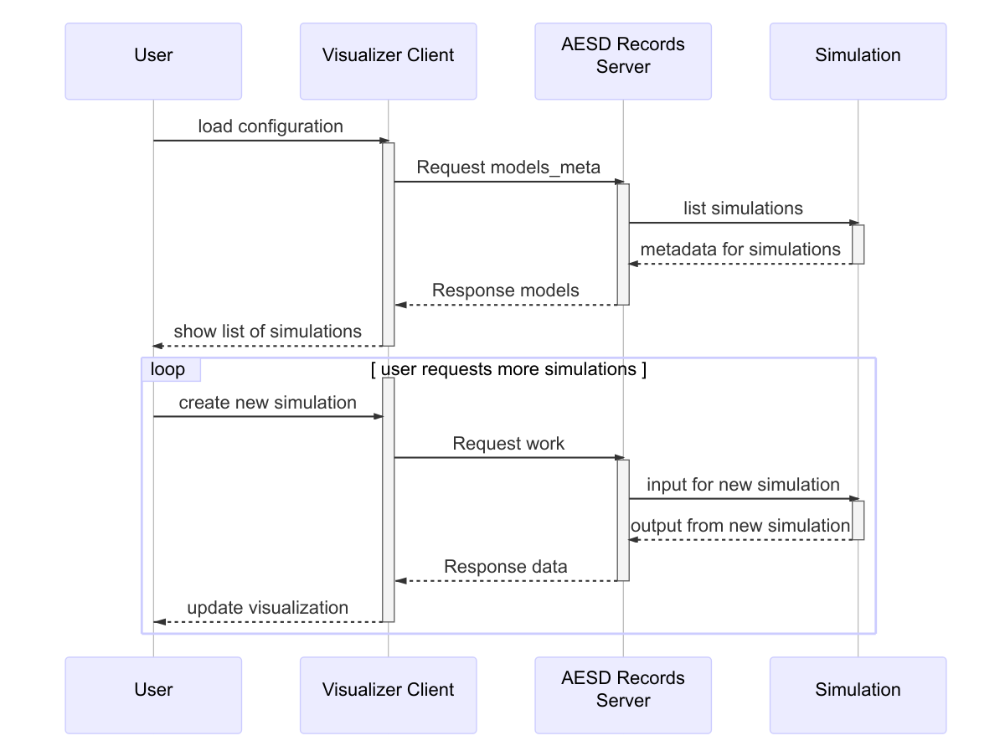

Steering and visualizing simulation results using the Records API

The RequestWork message, which is contained in the work field of a Request, specifies the input for a simulation to be run:

version: 4  
id: 3  
work {  
 model_id: "example-simulation-3"  
 inputs {  
 var_id: 0  
 value: 50  
 }  
}

The response to this message will be data for the result of the simulation.

Bookmarks

Once data from a model is loaded, it may be bookmarked. One simply supplies a description of the data to be bookmarked. Bookmarks can be listed and loaded, as shown in the following figure.

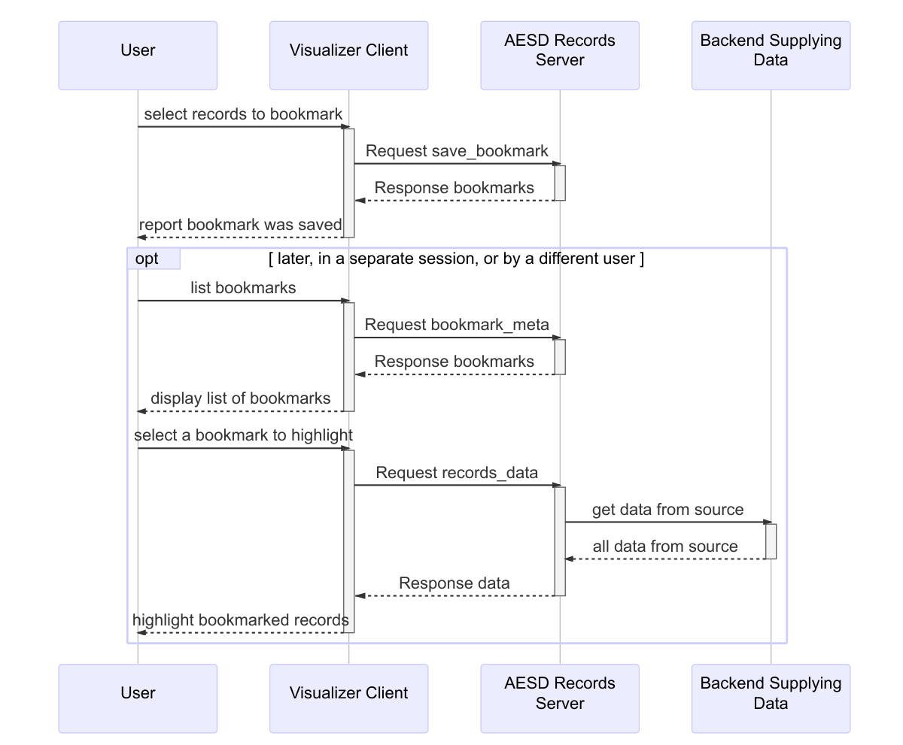

Creating and retrieving a bookmark and its associated data

To create a bookmark for a specific list of records, simply supply their record identifiers as part of a BookmarkMeta message in the save_bookmark field of Request:

version: 4  
id: 4  
save_bookmark {  
 model_id: "example-model-1"  
 new_bookmark {  
 bookmark_name: "Sample Bookmark"  
 set {  
 record_ids: 10  
 record_ids: 30  
 }  
 }  
}

The response will be the same bookmark but with the bookmark_id field added:

version: 4  
id: 4  
bookmarks {  
 bookmark_metas {  
 bookmark_id: "bookmark-1"  
 bookmark_name: "Sample Bookmark"  
 set {  
 record_ids: 10  
 record_ids: 30  
 }  
 }  
}

The user, or another user, can retrieve the records corresponding to the bookmark:

version: 4  
id: 5  
records_data {  
 model_id: "example-model-1"  
 bookmark_id: "bookmark-1"  
}

This will return precisely the bookmarked records:

version: 4  
id: 5  
data {  
 list {  
 records {  
 record_id: 10  
 variables {  
 var_id: 0  
 value: 10.5  
 }  
 variables {  
 var_id: 1  
 value: -5  
 }  
 variables {  
 var_id: 2  
 value: "first"  
 }  
 }  
 records {  
 record_id: 30  
 variables {  
 var_id: 0  
 value: -15.7  
 }  
 variables {  
 var_id: 1  
 value: 30  
 }  
 variables {  
 var_id: 2  
 value: "third"  
 }  
 }  
 }  
}

Filtering

Filtering records can be used to select particular records for retrieval, via the RequestRecordsData message, or in defining bookmarks via the BookmarkMeta message. Filtering of records is accomplished through expressions (FilterExpression), combining values for variables (DomainMeta), and the set operators *not*, *union*, and *intersection*, encoded in the messages FilterNot, FilterUnion, and FitlerIntersection respectively. For example, the expression would be expressed as the following FilterExpression:

filter_domain {  
 interval {  
 var_id: 0  
 last_value: 20  
 }  
}

provided that has var_id = 0. The expression would be expressed as

filter_union {  
 filter_expressions {  
 filter_domain {  
 var_id: 0  
 first_value: 10  
 last_value: 20  
 }  
 filter_not {  
 filter_expression {  
 filter_domain {  
 var_id: 1  
 set {  
 elements: 4  
 elements: 7  
 }  
   
 }  
 }  
 }  
}

provided that has var_id = 0 and has var_id = 1.

Records API, Version 4

The Records API consists of Google Protobuf 3 (Google Developers 2017b) messages used to request and provide data and metadata for record-oriented information. This section contains the complete specification for Version 4 of the Records API. Clients send Request messages and servers send Response messages, which are typically transported via WebSockets (Internet Engineering Task Force 2017).

Message Groups

The message types in the Records API are organized into thematic groups below.

Requests and Responses

Request messages are sent from client to server, and Response messages are sent from server to client. Request messages contain a specific type of request and response messages contain a corresponding specific type of response.

* Request
* RequestModelsMeta
* RequestRecordsData
* RequestWork
* RequestBoomarkMeta
* RequestSaveBookmark
* RequestCancel
* Response

Metadata

Metadata messages describe data sources (“models”) and variables.

* ModelMeta
* ModelMetaList
* DomainMeta
* VarMeta
* VariableType
* VarSet
* VarInterval

Data Records

Data are represented as either lists of records or tables of them.

* Record
* VarValue
* Value
* RecordData
* RecordList
* RecordTable

Filtering

Records can be filtered by logical operations on conditions for values of variables in the records.

* FilterExpression
* FilterNot
* FilterIntersection
* FilterUnion
* DomainMeta

Bookmarks

Bookmarks record particular sets or records or conditions for record data.

* BookmarkMeta
* BookmarkMetaList
* BookmarkIntervalContent
* BookmarkSetContent

Miscellaneous

The following messages wrap data types for the content of records.

* DoubleList
* IntegerList
* StringList
* OptionalInt32
* OptionalUInt32
* OptionalString

General Conventions

All fields are technically optional in ProtoBuf 3, but some fields may be required in each message type in order for the message to be semantically valid. In the following specifications for the messages, fields are annotated as *semantically required* or *semantically optional*. Also, the specification notes when field in the [protobuf oneof construct](https://developers.google.com/protocol-buffers/docs/proto3" \l "oneof) are required or mutually exclusive.

Furthermore, one cannot determine whether an optional value has been set if it is just a value, as opposed to a message. That is not true for fields that are messages, where the absence of the field truly indicates the value is absent and is not just a default or unset value. The message OptionalString, for example, is used in the API to indicate whether a character string value is truly present. Thus RequestModelsMeta has a model_id field that indicates whether the request is for all models, when the field has not been set, or for a specific one, when the field has been set.

Throughout this specification, the following types are used for identifiers: * var_id is int32 * model_id is string * record_id is int64

This specification conforms to [Protocol Buffers Version 3](https://developers.google.com/protocol-buffers/docs/proto3).

Messages

BookmarkIntervalContent

A range of record identifiers can specify the content of a bookmark. Bookmark interval content provides a convenient means to bookmark a contiguous selection of records in a model.

Both fields in this message are optional:

* If neither field is present, the bookmark interval designates all records in the model.
* If only first_record is present, the bookmark interval designates all records starting from that record identifier.
* If only last_record is present, the bookmark interval designates all records ending at that record identifier. For a dynamic model, such a bookmark interval includes all “future” records.
* If both fields are present, the bookmark interval designates all records between the two identifiers, inclusively.

| Field | Type | Label | Description |
| --- | --- | --- | --- |
| first_record | int64 | optional | [semantically optional] The identifier for the first record in the interval. |
| last_record | int64 | optional | [semantically optional] The identifier for the last record in the interval. |

### BookmarkMeta

A bookmark is metadata defining a subset of records in a model.

There are three alternatives to specifying a bookmark:

1. Interval content specifies a range of records in the bookmark.
2. Set content specifies a list of records in the bookmark.
3. A filter expression defines a set of logical conditions for determining whether a record is in the bookmark.

Exactly one of *interval*, *set*, or *filter* must be specified in this message.

|  |  |  |  |
| --- | --- | --- | --- |
| Field | Type | Label | Description |
| bookmark_id | string | optional | [semantically optional] When creating a new bookmark, this field must be empty; the server will create a unique identifier for the bookmark. This identifier uniquely identifies the bookmark *on the particular server*. |
| bookmark_name | string | optional | [semantically required] a name for the bookmark, which is useful for displaying the bookmark to users; this need not be unique, although it is recommended to be so. |
| interval | BookmarkIntervalContent | optional | the range of records in the bookmark |
| set | BookmarkSetContent | optional | the list of records in the bookmark |
| filter | FilterExpression | optional | logical conditions for defining which records are in the bookmark |

BookmarkMetaList

Bookmarks may be grouped into lists (sets).

|  |  |  |  |
| --- | --- | --- | --- |
| Field | Type | Label | Description |
| bookmark_metas | BookmarkMeta | repeated | [semantically optional] the bookmarks in the list |

BookmarkSetContent

A list (set) of record identifiers can specify the contents of a bookmark. Bookmark-set content provides a convenient means to bookmark a specific selection of non-continuous records in a model.

|  |  |  |  |
| --- | --- | --- | --- |
| Field | Type | Label | Description |
| record_ids | int64 | repeated | [semantically optional] the list of record identifiers in the set |

DomainMeta

The domain (set of valid values) for a variable.

There are two alternatives to specifying a domain:

1. An interval specifies a range of values in the domain.
2. A set specifies a list of values in the domain.

Exactly one of *interval* or *set* must be specified in the message.

|  |  |  |  |
| --- | --- | --- | --- |
| Field | Type | Label | Description |
| var_id | int32 | optional | [semantically required] |
| interval | VarInterval | optional | the interval of values in the domain |
| set | VarSet | optional | the list of values in the domain |

DoubleList

A list of real numbers.

|  |  |  |  |
| --- | --- | --- | --- |
| Field | Type | Label | Description |
| values | double | repeated | [semantically required] the real numbers |

### FilterExpression

A filtering expression is a composition of logical conditions on a record. It can be used to filter records. There are four alternatives to specifying a filter expression:

1. The logical negation of another filtering expression
2. The set union of multiple filtering expressions
3. The set intersection of multiple filtering expressions
4. Particular values of variables in a record.

Exactly one of *filter_not*, *filter_union*, *filter_intersection*, or *filter_domain* must be specified in this message.

|  |  |  |  |
| --- | --- | --- | --- |
| Field | Type | Label | Description |
| filter_not | FilterNot | optional | logical negation of an expression |
| filter_union | FilterUnion | optional | set union of expressions |
| filter_intersection | FilterIntersection | optional | set intersection of expressions |
| filter_domain | DomainMeta | optional | particular values of variables |

FilterIntersection

Set intersection of filtering expressions. A record satisfies this expression if it satisfies all filter_expressions.

|  |  |  |  |
| --- | --- | --- | --- |
| Field | Type | Label | Description |
| filter_expressions | FilterExpression | repeated | [semantically required] the expressions to be intersected |

FilterNot

Logically negate a filtering expression. A record satisfies this expression if it does not satisfy filter_expression.

|  |  |  |  |
| --- | --- | --- | --- |
| Field | Type | Label | Description |
| filter_expression | FilterExpression | optional | [semantically required] the expression to be negated |

FilterUnion

Set union of filtering expressions. A record satisfies this expression if it satisfies any of filter_expressions.

|  |  |  |  |
| --- | --- | --- | --- |
| Field | Type | Label | Description |
| filter_expressions | — | repeated | [semantically required] the expressions to be “unioned” |

IntegerList

A list of integers.

|  |  |  |  |
| --- | --- | --- | --- |
| Field | Type | Label | Description |
| values | sint64 | repeated | [semantically required] The integers |

ModelMeta

Metadata for a model.

|  |  |  |  |
| --- | --- | --- | --- |
| Field | Type | Label | Description |
| model_id | string | optional | [semantically required] the unique identifier for the model *on the particular server* |
| model_name | string | optional | [semantically required] a name for the model, useful for display the model to users; this need not be unique, although it is recommended to be so. |
| model_uri | string | optional | [semantically required] the unique URI for the model; additional metadata may be obtained by dereferencing that URI. |
| variables | VarMeta | repeated | [semantically required] metadata for the variables |
| inputs | DomainMeta | repeated | [semantically optional] metadata for input values to the model, if any |

ModelMetaList

A list of metadata for models.

|  |  |  |  |
| --- | --- | --- | --- |
| Field | Type | Label | Description |
| models | ModelMeta | repeated | [semantically optional] the metadata for the models |

OptionalInt32

Wrapper for an optional signed integer.

|  |  |  |  |
| --- | --- | --- | --- |
| Field | Type | Label | Description |
| value | int32 | optional | [semantically required] the signed integer value |

OptionalString

Wrapper for an optional string.

|  |  |  |  |
| --- | --- | --- | --- |
| Field | Type | Label | Description |
| value | string | optional | [semantically required] the character string value |

OptionalUInt32

Wrapper for an optional unsigned integer.

|  |  |  |  |
| --- | --- | --- | --- |
| Field | Type | Label | Description |
| value | uint32 | optional | [semantically required] the unsigned integer valuet |

Record

A record is a list of variables and their associated values.

|  |  |  |  |
| --- | --- | --- | --- |
| Field | Type | Label | Description |
| record_id | int64 | optional | [semantically required] a unique identifier for the record |
| variables | VarValue | repeated | [semantically optional] the values for variables in the record |

RecordData

A collection of records.

There are two alternatives to specifying record data:

1. A list specifies a heterogeneously typed list.
2. A table specifies a homogeneously typed table.

Exactly one of *list* or *table* must be present in the message.

|  |  |  |  |
| --- | --- | --- | --- |
| Field | Type | Label | Description |
| list | RecordList | optional | a heterogeneously typed list of records |
| table | RecordTable | optional | a homogeneously typed table of records |

RecordList

A list of records. The list is heterogeneous in the sense that each variable may have a different type.

|  |  |  |  |
| --- | --- | --- | --- |
| Field | Type | Label | Description |
| records | Record | repeated | [semantically optional] The list of records. |

RecordTable

A homogeneously typed table of records, where each variable has each type, with a row for each record and a column for each variable.

This message represents the following table:

|  |  |  |  |  |
| --- | --- | --- | --- | --- |
| Record Identifier | var_id[0] | var_id[1] | . . . | var_id[N] |
| rec_id[0] | list[0][0] | list[0][1] | . . . | list[0][N] |
| rec_id[1] | list[1][0] | list[1][1] | . . . | list[1][N] |
| . . . | . . . | . . . | . . . | . . . |
| rec_id[M] | list[M][0] | list[M][1] | . . . | list[M][N] |

The underlying list is a **single** array, addressable using the following [row-major index formula](https://en.wikipedia.org/wiki/Row-_and_column-major_order) list[row][var] = array[var + NY * row] where NX = length of rec_ids and NY = length of var_ids.

Exacly one of *reals*, *integers*, or *strings* must be specified in the message.

| Field | Type | Label | Description |
| --- | --- | --- | --- |
| var_ids | int32 | repeated | [semantically required] the identifiers of the variables (columns) in the table |
| rec_ids | int64 | repeated | [semantically required] the identifiers of the records (rows) in the table |
| reals | DoubleList | optional | the real numbers comprising the values of the variables, in [row-major order](https://en.wikipedia.org/wiki/Row-_and_column-major_order) |
| integers | IntegerList | optional | the integers comprising the values of the variables, in [row-major order](https://en.wikipedia.org/wiki/Row-_and_column-major_order) |
| strings | StringList | optional | the character strings comprising the values of the variables, in [row-major order](https://en.wikipedia.org/wiki/Row-_and_column-major_order) |

Request

A request. There are six types of requests:

|  |  |
| --- | --- |
| Request | Response |
| Metadata for model(s) | ModelMetaList |
| Data records | RecordData |
| Metadata for bookmark(s) | BookmarkMetaList |
| Saving a bookmark | BookmarkMetaList |
| Canceling a previous request | n/a |
| New work, such as a simulation | RecordData |

Exactly one of models_metadata, records_data, bookmark_meta, save_bookmark, cancel, or work must be specified in the message.

| Field | Type | Label | Description |
| --- | --- | --- | --- |
| version | uint32 | optional | [semantically required] the version number for the API; *this must be the number* ***four****.* |
| id | OptionalUInt32 | optional | [semantically optional, but recommended] an identifier that will be used to tag responses, so that responses can be correlated with requests |
| subscribe | bool | optional | [semantically optional] whether to continue receiving responses indefinitely, as new records become available; this is useful, for example, when a sensor is reporting measurements periodically or when simulations are reporting a series or results. Use RequestCancel to end the subscription. |
| models_metadata | RequestModelsMeta | optional | request metadata for model(s) |
| records_data | RequestRecordsData | optional | request data records |
| bookmark_meta | RequestBookmarkMeta | optional | request metadata for bookmark(s) |
| save_bookmark | RequestSaveBookmark | optional | request save a new bookmark or update an existing one |
| cancel | RequestCancel | optional | request to cancel a previous request) |
| work | RequestWork | optional | request work (e.g., simulation results) |

RequestBookmarkMeta

A request for one or more bookmarks for a model.

The response to this request is BookmarkMetaList

|  |  |  |  |
| --- | --- | --- | --- |
| Field | Type | Label | Description |
| model_id | string | optional | [semantically required] which model for which to list bookmarks |
| bookmark_id | OptionalString | optional | [semantically optional] If empty, list all bookmarks for the model. Otherwise, list just the bookmark metadata for this specific bookmark identifier. |

RequestCancel

Cancel a previous request.

|  |  |  |  |
| --- | --- | --- | --- |
| Field | Type | Label | Description |
| id | OptionalUInt32 | optional | [semantically required] which request to cancel |

RequestModelsMeta

A request for metadata about model(s).

The response to this request is ModelMetaList.

|  |  |  |  |
| --- | --- | --- | --- |
| Field | Type | Label | Description |
| model_id | OptionalString | optional | [semantically optional] If absent, the request is for metadata for all models. Otherwise, the request is for the specifically identified model. |

RequestRecordsData

Request record data for a model.

There are three alternatives to requesting record data:

1. Request all records.
2. Request records in a bookmark.
3. Filter records according to a criterion.

The response to this request is RecordData.

No more than one of *bookmark_id* or *expression* may be present in the message.

|  |  |  |  |
| --- | --- | --- | --- |
| Field | Type | Label | Description |
| model_id | string | optional | [semantically required] the identifier for the model |
| max_records | uint64 | optional | [semantically optional] If specified, this is the maximum number of records to return. Otherwise, all records are returned, although they may be returned as multiple responses, each with a chunk of records. |
| var_ids | int32 | repeated | [semantically optional] which variables to include in the response; if this is not specified, all variables will be included. |
| bookmark_id | string | optional | [semantically optional] Only respond with records in a specified bookmark. |
| expression | FilterExpression | optional | [semantically optional] Only respond with records matching a specified criterion. |

RequestSaveBookmark

A request to create or update a bookmark.

The response to this request is BookmarkMetaList.

|  |  |  |  |
| --- | --- | --- | --- |
| Field | Type | Label | Description |
| model_id | string | optional | [semantically required] which model for which to save the bookmark |
| new_bookmark | BookmarkMeta | optional | [semantically optional] If empty, create a new bookmark. (In which case, leave the bookmark_id empty, so that the server will create a unique identifier for the new bookmark.) Otherwise, update an existing bookmark. |

RequestWork

Request that the server compute new records based on input values.

The response to this request is RecordData.

|  |  |  |  |
| --- | --- | --- | --- |
| Field | Type | Label | Description |
| model_id | string | optional | [semantically required] the identifier for the model |
| inputs | VarValue | repeated | [semantically optional] which input variables to set to which values |

Response

A response to a request.

Note that a server may send multiple responses to a single request, expressed as a linked list of chunks. It is strongly recommended that servers chunk by record_id so that each record is kept intact. A chunk may be empty.

|  |  |  |  |
| --- | --- | --- | --- |
| Field | Type | Label | Description |
| version | uint32 | optional | [semantically required] the version number for the API; *this must be the number* ***four****.* |
| id | OptionalUInt32 | optional | [semantically optional] a response without an identifier is a notification; otherwise, the response identifier matches the response identifier for the original request. |
| chunk_id | int32 | optional | [semantically optional, but recommended] the identifier for this chunk; it is recommended that chunks are numbered sequentially starting beginning with the number one. |
| next_chunk_id | int32 | optional | [semantically optional] the identifier of the next chunk, or zero if this is the last chunk |
| error | string | optional | an error message |
| models | ModelMetaList | optional | a list of model metadata |
| data | RecordData | optional | a list of record data |
| bookmarks | BookmarkMetaList | optional | a list of bookmark metadata |

StringList

A list of character strings.

|  |  |  |  |
| --- | --- | --- | --- |
| Field | Type | Label | Description |
| values | string | repeated | [semantically required] the character stringst |

Value

Value that may be a real number, an integer, or a character string

Exactly one of *real_value*, *integer_value*, or *string_value* must be specified in this message.

|  |  |  |  |
| --- | --- | --- | --- |
| Field | Type | Label | Description |
| real_value | double | optional | the real number |
| integer_value | int64 | optional | the integer |
| string_value | string | optional | the character string |

VarInterval

A range of values of a variable.

Both fields in this message are optional:

* If neither field is present, the interval designates all values in the domain.
* If only first_value is present, the interval designates all values starting from that value.
* If only last_value is present, the bookmark interval designates all values ending at that value.
* If both fields are present, the interval designates all values between the two values, inclusive.

|  |  |  |  |
| --- | --- | --- | --- |
| Field | Type | Label | Description |
| first_value | Value | optional | [semantically optional] the first value in the interval |
| last_value | Value | optional | [semantically optional] the last value in the interval |

VarMeta

Metadata for a variable.

|  |  |  |  |
| --- | --- | --- | --- |
| Field | Type | Label | Description |
| var_id | int32 | optional | [semantically required] an integer identifying the variable |
| var_name | string | optional | [semantically required] the name of the variable |
| units | string | optional | [semantically optional] the name of the unit of measure for values of the variable |
| si | sint32 | repeated | [semantically optional] the unit of measure expressed as a list of the exponents for the eight fundamental SI quantities [meter, kilogram, second, ampere, kelvin, mole, candela, radian]; for example, the unit of acceleration would be express as [1, 0, -2, 0, 0, 0, 0, 0] because meters has an exponent of positive one and seconds has an exponent of negative two. |
| scale | double | optional | [semantically optional] An overall scale relative to the fundamental SI scale of the unit of measure; for instance, kilometers would have a scale of 1,000 because the fundamental unit of distance is meters. |
| type | VariableType | optional | [semantically optional] the data type for values of the variable; The default type is real number. |

VarSet

A set of values for a variable.

|  |  |  |  |
| --- | --- | --- | --- |
| Field | Type | Label | Description |
| elements | Value | repeated | [semantically optional] the list of values in the set |

VarValue

The value of a variable.

|  |  |  |  |
| --- | --- | --- | --- |
| Field | Type | Label | Description |
| var_id | int32 | optional | [semantically required] the identifier for the variable |
| value | Value | optional | [semantically required] the value of the variable |

VariableType

The data type for a value.

|  |  |  |
| --- | --- | --- |
| Name | Number | Description |
| REAL | 0 | a real number |
| INTEGER | 1 | an integer |
| STRING | 2 | a character string |

Scalar Value Types

| .proto Type | Notes | C++ Type | Java Type | Python Type |
| --- | --- | --- | --- | --- |
| double |  | double | double | float |
| float |  | float | float | float |
| int32 | Uses variable-length encoding. Inefficient for encoding negative numbers—if your field is likely to have negative values, use sint32 instead. | int32 | int | int |
| int64 | Uses variable-length encoding. Inefficient for encoding negative numbers; if your field is likely to have negative values, use sint64 instead. | int64 | long | int/long |
| uint32 | Uses variable-length encoding. | uint32 | int | int/long |
| uint64 | Uses variable-length encoding. | uint64 | long | int/long |
| sint32 | Uses variable-length encoding. Signed int value. These more efficiently encode negative numbers than regular int32s. | int32 | int | int |
| sint64 | Uses variable-length encoding. Signed int value. These more efficiently encode negative numbers than regular int64s. | int64 | long | int/long |
| fixed32 | Always four bytes. More efficient than uint32 if values are often greater than 2^28. | uint32 | int | int |
| fixed64 | Always eight bytes. More efficient than uint64 if values are often greater than 2^56. | uint64 | long | int/long |
| sfixed32 | Always four bytes. | int32 | int | int |
| sfixed64 | Always eight bytes. | int64 | long | int/long |
| bool |  | bool | Boolean | Boolean |
| string | A string must always contain UTF-8 encoded or 7-bit ASCII text. | string | String | str/unicode |
| bytes | May contain any arbitrary sequence of bytes. | string | ByteString | str |

Implementations

This section provides an overview of the variety of libraries and applications implementing the Records API (see the table below). In particular, pre-built applications are available for serving text-based data sources, database queries, and sensor data feeds. Application Container Images (ACIs) (CoreOS 2017a) of each have been packed for use with the rkt container engine (CoreOS 2017b).

Available Client and Server Applications and Libraries for the Records API

| Client or Server? | Library or Application? | Data Source | Implementation Language | Computing Platforms | URL |
| --- | --- | --- | --- | --- | --- |
| client | GUI application | any | C++ | Mac, Winodws, Linux | <https://github.nrel.gov/d-star/cpp-records> |
| server | GUI/CLI applications | CSV files | C++ | Mac, Winodws, Linux | <https://github.nrel.gov/d-star/cpp-records> |
| client | library | any | Haskell | Mac, Windows, Linux | <https://github.com/NREL/AESD/lib/haskell> |
| server | CLI application | TSV files | Haskell | Mac, Windows, Linux | <https://github.com/NREL/AESD/lib/haskell> |
| server | CLI application | PostgreSQL | Haskell | Mac, Windows, Linux | <https://github.com/NREL/AESD/lib/haskell> |
| server | CLI application | MySQL | Haskell | Mac, Windows, Linux | <https://github.com/NREL/AESD/lib/haskell> |
| server | CLI application | SQLite3 | Haskell | Mac, Windows, Linux | <https://github.com/NREL/AESD/lib/haskell> |
| server | CLI application | ODBC | Haskell | Mac, Windows, Linux | <https://github.com/NREL/AESD/lib/haskell> |
| server | CLI application | Haystack | Haskell | Mac, Windows, Linux | <https://github.com/NREL/AESD/lib/haskell> |
| client | library, web application | any | JavaScript | Chrome, Firefox | <https://github.com/NREL/AESD/lib/javascript> |
| client | library | any | Python | any | <https://github.com/NREL/AESD/lib/python> |
| client | library | any | R | any | <https://github.nrel.gov/d-star/r-records> |

Haskell Client and Server Library and Applications

Both client and server applications in Haskell are available for the Records API. Full documentation resides at <https://github.com/NREL/AESD/lib/haskell>.

Client Library

The client library described below provides the basic functions for interacting with any Records API server.

Types

**data State**

State information for a client.

Entry Point

**clientMain**

Run a client.

|  |  |
| --- | --- |
| Argument Type | Description |
| :: String | the WebSocket host address |
| -> Int | the WebSocket port number |
| -> String | the WebSocket path |
| -> (State -> IO ()) | customize the client |
| -> IO () | action for running the client |

**close**

Close a client.

|  |  |
| --- | --- |
| Argument Type | Description |
| :: State | the state of the client |
| -> IO () | action for closing the client |

Server Requests

**fetchModels**

Fetch model metadata.

|  |  |
| --- | --- |
| Argument Type | Description |
| :: State | the state of the client |
| -> IO (Either String [ModelMeta]) | action returning either an error or the models |

**fetchRecords**

Fetch records from the server.

|  |  |
| --- | --- |
| Argument Type | Description |
| :: State | the state of the client |
| -> ModelIdentifier | the model identifier |
| -> Maybe Int | the maximum number of records to request |
| -> IO (Either String [RecordContent]) | action returning either an error or the records |

**fetchBookmarks**

Fetch bookmark(s).

|  |  |
| --- | --- |
| Argument Type | Description |
| :: State | the state of the client |
| -> ModelIdentifier | the model identifier |
| -> Maybe BookmarkIdentifier | the bookmark identifier, or all bookmarks |
| -> IO (Either String [BookmarkMeta]) | action returning either an error or the bookmark(s) |

**storeBookmark**

Save a bookmark.

| Argument Type | Description |
| --- | --- |
| :: State | the state of the client |
| -> ModelIdentifier | the model identifier |
| -> BookmarkMeta | the bookmark metadata |
| -> IO (Either String BookmarkMeta) | action returning either an error or the bookmark |

Server Library

The server library provides two options for implementing a Records API server. The AESD.Records.Server module provides a main entry point serverMain, a type class ModelManager, and a monad ServiceM that implement a skeletal server, which handles all of the WebSocket communication and Protocol Buffer serialization; an implementer need only create an instance of ModelManager. Furthermore, the AESD.Records.Server.Manager module provides such an instance InMemoryManager of the type class ModelManger to handle in-memory caching of data and on-disk persistence of bookmarks; here, an implementer just calls the function makeInMemoryManager and provides several functions that retrieve content:

**makeInMemoryManager**

Construct an in-memory model manager.

|  |  |
| --- | --- |
| Argument Type | Description |
| :: Maybe FilePath | the name of the journal file |
| -> a | the initial state |
| -> (a -> IO ([ModelMeta], a)) | list models in an action modifying the state |
| -> (a -> ModelMeta -> IO ([RecordContent], a)) | load record data in an action modifying the state |
| -> (a -> ModelMeta -> [VarValue] -> IO ([RecordContent], a)) | performing work in an action modifying the state |
| -> IO (InMemoryManager a) | action constructing the manager |

Server Back Ends

As previously mentioned, prebuilt servers have been implemented for standard types of data sources.

Tab-Separate-Value Files

Serving tab-separated-value (TSV) files is as simple as placing the TSV files in a directory and starting a server at the command line, with the arguments specified in the table below:

aesd-file-server <host> <port> <directory> <persistence> <chunkSize>

Command-Line Arguments for Serving TSV Files

|  |  |
| --- | --- |
| Parameter | Description |
| host | host address to which to bind the service |
| port | port to which to bind the service |
| directory | directory with TSV files to be served |
| persistence | filename for bookmark data |
| chunkSize | number of records return in each chunk |

Database Queries

The Records API servers have been implemented for the most common database back ends. Each server takes a single command-line argument specifying a YAML (Oren Ben-Kiki, Clark Evans, Ingy döt Net 2017) configuration file with the parameters in the table below.

Parameters for Database Back Ends Serving the Records API

| Parameter | Description | PostgreSQL | MySQL | SQLite3 | ODBC |
| --- | --- | --- | --- | --- | --- |
| host | host address to which to bind the service | required | required | required | required |
| port | port to which to bind the service | required | required | required | required |
| directory | directory with queries to be served | required | required | required | required |
| persistence | filename for bookmark data | optional | optional | optional | optional |
| chunkSize | number of records return in each chunk | optional | optional | optional | optional |
| database | database connection information | required connection string | required connection string | required filename | required connection string |

Haystack Sensor Measurements and the “Internet of Things”

Furthermore, a server for Project Haystack (Project Haystack 2017) data feeds, typically sensor measurements from devices in the “internet of things,” has been implemented. The server takes command-line arguments specified in the table below.

aesd-haystack-server <configuration> <host> <port> <startTime> <persistence> <chunkSize>

Command-Line Arguments for Serving Haystack Data Feeds

|  |  |
| --- | --- |
| Parameter | Description |
| configuration | YAML configuration file for accessing the Haystack service |
| host | host address to which to bind the service |
| port | port to which to bind the service |
| startTime | earliest time to serve, specified in seconds of the POSIX Epoch |
| persistence | filename for bookmark data |
| chunkSize | number of records return in each chunk |

The parameters in the YAML configuration file like the one below and are described in the following table:

siteAccess :  
 server : xv11skys01.nrel.gov  
 root : /api/nrel_wt_V7  
 authorization: ["my username","my password"]  
 secure : false  
 timeZone : [-360, true, Denver]  
siteIdentifier : NWTCv4  
siteURI : http://aesd.nrel.gov/records/v4/nwtc/  
siteName : NREL NWTC  
siteDescription: Sensors from NREL National Wind Technology Center  
siteTags :  
 ! 'DC.source' : https://xv11skys01.nrel.gov/proj/nrel_wt_v7  
 ! 'DC.creator' : Brian W Bush <brian.bush@nrel.gov>  
 ! 'DC.description': NREL NWTC sensors  
siteMeters :  
 - 1dca834e-c6af46d6 NWTC Alstom Turbine Electricity Meter Turbine-Alstom kW Demand Forward  
 - 1dca834e-69a3e57e NWTC Alstom Turbine Electricity Meter Turbine-Alstom kW Demand Reverse  
 - 1dca834e-f56e11f0 NWTC Alstom Turbine Electricity Meter Turbine-Alstom kWh Delivered Forward

YAML Configuration Parameters for Haystack-Based Records API Servers

|  |  |  |
| --- | --- | --- |
| Parameter | Description | Required? |
| server | hostname and port for the Haystack server | required |
| root | path to the Haystack REST service | required |
| authorization | the username and password for accessing the Haystack REST service | optional |
| secure | whether to use HTTPS instead of HTTP | optional |
| time zone | time zone information: minutes offset from UTC, whether to use daylight savings time, and the geographic location | required |
| siteIdentifier | identifier for the Records API server | required |
| siteURI | URI for the Records API server metadata | required |
| siteName | name of the Records API server | required |
| siteTags | key-value pairs tagging the server with additional information | optional |
| siteMeters | list of meters to expose on the Records API server; the Haystack ID is followed by a space and textual description. | required |

C++ Server and Client

Both client and server applications have been implemented in C++ for the Records API. See <https://github.nrel.gov/d-star/cpp-records> for details. There are GUI and command-line applications for serving comma-separated-value files and a GUI application for browsing Records API data sources.

JavaScript Client Library and Web-Based Browser

The client library for JavaScript relies on a few simple functions to interact with a Records API server. Full documentation for the JavaScript client library is available at <http://github.com/NREL/AESD/lib/javascript>. The figure below shows the user interface of the general purpose Records API browser using this JavaScript library.

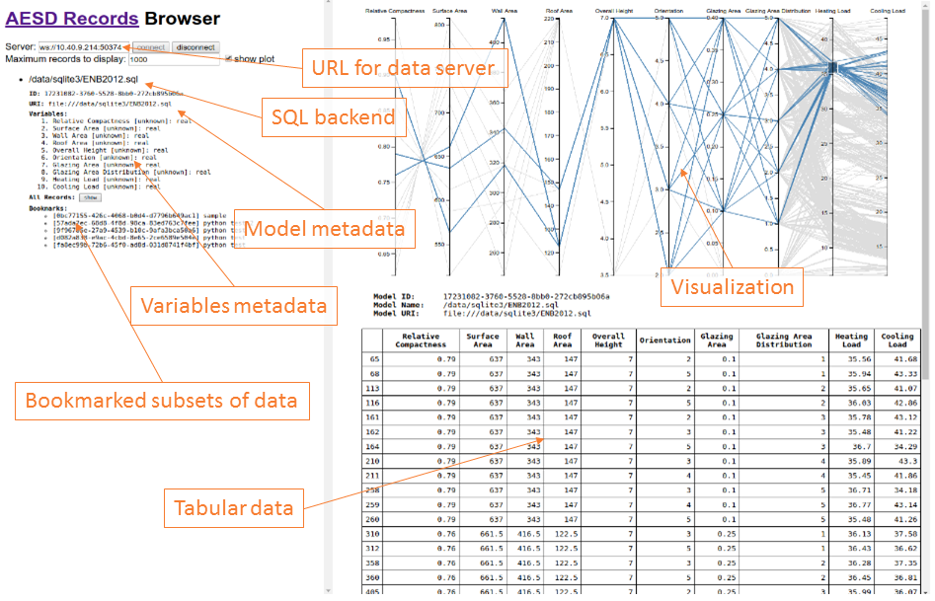

User interface for the Records API browser

Connect to a server

**connect(wsURL)**

Here, wsURL is simply the URL of the server (e.g., ws://10.40.9.214:503761). This returns a connection object.

Disconnect from a server

**disconnect(connection)**

Here, connection is the connection object returned by the connect function.

Retrieve list of data models

**requestModelsMetadata(connection, modelId, notify, notifyError)**

Here, connection is the connection object returned by the connect function and modelId is either the string identifying the model or null if metadata for all models is requested. After all of the model metadata have been retrieved, the notify function is called with the list of model metadata objects as its argument; if an error occurs, notifyError is called with the error message as its argument. The function requestModelsMetadata returns a result object that contains a field done indicating whether all model metadata have been retrieved and a field models listing the model metadata retrieved so far.

Retrieve data records

**requestRecordsData(connection, modelId, maxRecords, variableIds, bookmarkId, notify, notifyError)**

Here, connection is the connection object return by the connect function and modelId is the string identifying the model. After all of the data records have been retrieved, the notify function is called with the list of data records as its argument; if an error occurs, notifyError is called with the error message as its argument. The maxRecords argument specifies the maximum number of records to retrieve, variableIds may list the variables of interest, and bookmarkId restricts the results to bookmarked records. The function requestRecordsData returns a result object that contains a field done indicating whether all data records have been retrieved and a field data listing the data records retrieved so far.

Retrieve list of bookmarks

**requestBookmarkMeta(connection, modelId, bookmarkId, notify, notifyError)**

Here, connection is the connection object returned by the connect function, modelId is the string identifying the model, and bookmarkId is either the string identifying the bookmark or null if metadata for all bookmarks is requested. After all of the bookmark metadata have been retrieved, the notify function is called with the list of bookmark metadata as its argument; if an error occurs, notifyError is called with the error message as its argument. The function requestBookmarkMeta returns a result object that contains a field done indicating whether all bookmark metadata have been retrieved and a field bookmarks listing the bookmark metadata retrieved so far.

Create/update a bookmark

**requestSaveBookmark(connection, modelId, name, filter, notify, notifyError)**

Here, connection is the connection object returned by the connect function, modelId is the string identifying the model, and bookmarkId is either null for a new bookmark or the identifier for a bookmark being updated. The name field names the bookmark and the filter object describing the filtering operation for the bookmark. After the bookmark metadata has been created or updated, the notify function is called with the list of bookmark metadata as its argument; if an error occurs, notifyError is called with the error message as its argument. The function requestSaveBookmark returns a result object that contains a field done indicating whether all bookmark metadata have been retrieved and a field bookmarks listing the bookmark metadata retrieved so far.

Python Client Library

Full documentation for the Python client library is available at <http://github.com/NREL/AESD/lib/python>.

Client API

**new_server(self, server_url)**

Change server URL to which WebSocket will connect  
Parameters  
----------  
server_url : 'string'  
 server url  
   
Returns  
---------  
self.url : 'string'  
 server url

**send(self, request)**

Closes event_loop  
Parameters  
----------  
request : 'proto.request'  
 proto request message  
timeout : 'int'  
 timeout in seconds for connection  
   
Returns  
---------  
response : 'list'  
 List of responses from the server, each response is a proto message

**get_model_info(self, model_id)**

Sends request of model metadata and extracts response  
Parameters  
----------  
model_id : 'string'  
 Id of model for which to request models_metadata  
 if None requests all models  
   
Returns  
-------  
model_info : 'list'|'dict'  
 List of model's metadata dictionaries for each model in models or  
 dictionary for model_id

**get_data(self, model_id, max_records=1000, variable_ids=None, bookmark_id=None)**

Sends request of model metadata and extracts response  
Parameters  
----------  
model_id : 'string'  
 Id of model for which to request records_data  
max_records : 'int'  
 Number or records being request (0 will return all records)  
variable_ids : 'list'  
 List of variable ids (ints) to be requested  
 Will be returned in same order as request  
 Default=None, all variables will be returned (order?)  
bookmark_id : 'int'  
 Request records_data based on bookmark id  
   
Returns  
-------  
data : 'pd.DataFrame'  
 Concatenated data from each response message  
 Variable ids replaced with names from model_info

**do_work(self, model_id, inputs)**

Sends request of model metadata and extracts response  
Parameters  
----------  
model_id : 'string'  
 Id of model for which to request records_data  
inputs : 'dict'  
 Dictionary of {var_id: value} pairs  
   
Returns  
-------  
data : 'pd.DataFrame'  
 Concatenated data from each response message  
 Variable ids replaced with names from model_info

**get_bookmark_info(self, model_id, bookmark_id)**

Sends request of model metadata and extracts response  
Parameters  
----------  
model_id : 'string'  
 Id of model for which to request bookmark_meta  
bookmark_id : 'string'  
 Id of bookmark for which to request models_metadata  
 if None request all bookmarks  
   
Returns  
-------  
model_info : 'list'|'dict'  
 List of model's metadata dictionaries for each model in models or  
 dictionary for model_id

**save_bookmark(self, model_id, name, content)**

Sends request to save new bookmark  
Parameters  
----------  
model_id : 'string'  
 Id of model for which to request bookmark_meta  
name : 'string'  
 Name for new bookmark  
content : 'list'|'tuple'  
 Contents of bookmark  
 list is a bookmark set  
 tuple is a bookmark interval  
   
Returns  
-------  
model_info : 'list'|'dict'  
 List of model's metadata dictionaries for each model in models or  
 dictionary for model_id

Example

The figure below shows example usage of the Python Records API client.

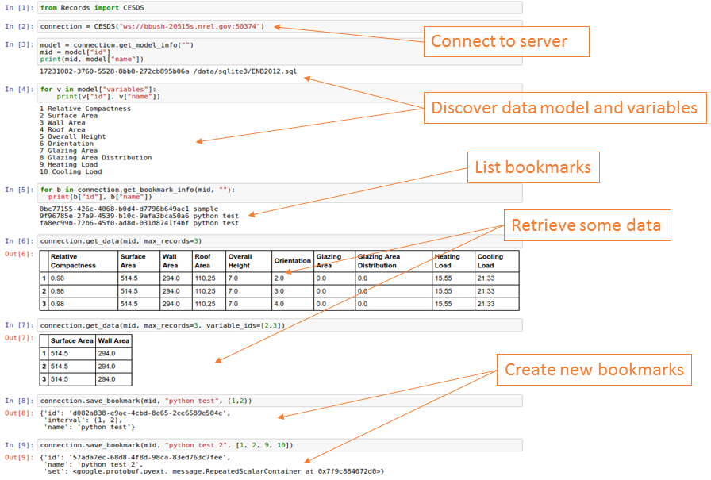

Example of a Python session using the Records API

Appendix

Protocol Buffers for Records API Version 4

syntax = "proto3";  
package AesdRecords;  
  
option optimize_for = LITE_RUNTIME;  
  
message OptionalInt32 {  
 int32 value = 1; /// [semantically required]  
}  
  
message OptionalUInt32 {  
 uint32 value = 1; /// [semantically required]  
}  
  
message OptionalString {  
 string value = 1; /// [semantically required]  
}  
  
message Value {  
 oneof value /// [semantically required]  
 {  
 double real_value = 1;   
 int64 integer_value = 2;   
 string string_value = 3;   
 }  
}  
  
message DoubleList {  
 repeated double values = 1; /// [semantically required]  
}  
  
message IntegerList {  
 repeated sint64 values = 1; /// [semantically required]  
}  
  
message StringList {  
 repeated string values = 1; /// [semantically required]  
}  
  
message BookmarkIntervalContent {  
 int64 first_record = 1; /// [semantically optional]  
 int64 last_record = 2; /// [semantically optional]  
}  
  
message BookmarkSetContent {  
 repeated int64 record_ids = 1; /// [semantically optional]  
}  
  
message BookmarkMeta {  
 string bookmark_id = 1; /// [semantically optional]  
 string bookmark_name = 2; /// [semantically required]  
 oneof content /// [semantically required]  
 {  
 BookmarkIntervalContent interval = 3;   
 BookmarkSetContent set = 4;   
 FilterExpression filter = 5;   
 }  
}  
  
message BookmarkMetaList {  
 repeated BookmarkMeta bookmark_metas = 1; /// [semantically optional]  
}  
  
message RequestBookmarkMeta {  
 string model_id = 1; /// [semantically required]  
 OptionalString bookmark_id = 2; /// [semantically optional]  
}  
  
message RequestSaveBookmark {  
 string model_id = 1; /// [semantically required]  
 BookmarkMeta new_bookmark = 2; /// [semantically optional]  
}  
  
message FilterExpression {  
 oneof expression /// [semantically required]  
 {  
 FilterNot filter_not = 1;   
 FilterUnion filter_union = 2;   
 FilterIntersection filter_intersection = 3;   
 DomainMeta filter_domain = 4;   
 }  
}  
  
message FilterNot {  
 FilterExpression filter_expression = 1; /// [semantically required]  
}  
  
message FilterUnion {  
 repeated FilterExpression filter_expressions = 1; /// [semantically required]  
}  
  
message FilterIntersection {  
 repeated FilterExpression filter_expressions = 1; /// [semantically required]  
}  
  
enum VariableType  
{  
 REAL = 0;   
 INTEGER = 1;   
 STRING = 2;   
}  
  
message VarMeta {  
 int32 var_id = 1; /// [semantically required]  
 string var_name = 2; /// [semantically required]  
 string units = 3; /// [semantically optional]  
 repeated sint32 si = 4; /// [semantically optional]  
 double scale = 5; /// [semantically optional]  
 VariableType type = 6; /// [semantically optional]  
}  
  
message ModelMeta {  
 string model_id = 1; /// [semantically required]  
 string model_name = 2; /// [semantically required]  
 string model_uri = 3; /// [semantically required]  
 repeated VarMeta variables = 4; /// [semantically required]  
 repeated DomainMeta inputs = 5; /// [semantically optional]  
}  
  
message ModelMetaList {  
 repeated ModelMeta models = 1; /// [semantically optional]  
}  
  
message RequestModelsMeta {  
 OptionalString model_id = 1; /// [semantically optional]  
}  
  
message VarInterval {  
 Value first_value = 1; /// [semantically optional]  
 Value last_value = 2; /// [semantically optional]  
}  
  
message VarSet {  
 repeated Value elements = 1; /// [semantically optional]  
}  
  
message DomainMeta {  
 int32 var_id = 1; /// [semantically required]  
 oneof domain /// [semantically required]  
 {  
 VarInterval interval = 2;   
 VarSet set = 3;   
 }  
}  
  
message RequestWork {  
 string model_id = 1; /// [semantically required]  
 repeated VarValue inputs = 2; /// [semantically optional]  
}  
  
message VarValue {  
 int32 var_id = 1; /// [semantically required]  
 Value value = 2; /// [semantically required]  
}  
  
message Record {  
 int64 record_id = 1; /// [semantically required]  
 repeated VarValue variables = 2; /// [semantically optional]  
}  
  
message RecordList {  
 repeated Record records = 1; /// [semantically optional]  
}  
  
message RecordTable {  
 repeated int32 var_ids = 1; /// [semantically required]  
 repeated int64 rec_ids = 2; /// [semantically required]  
 oneof list /// [semantically required]  
 {  
 DoubleList reals = 3;   
 IntegerList integers = 4;   
 StringList strings = 5;   
 }  
}  
  
message RecordData {  
 oneof style /// [semantically required]  
 {  
 RecordList list = 1;   
 RecordTable table = 2;   
 }  
}  
  
message RequestRecordsData {  
 string model_id = 1; /// [semantically required]  
 uint64 max_records = 2; /// [semantically optional]  
 repeated int32 var_ids = 3; /// [semantically optional]  
 oneof filter /// [semantically optional]  
 {  
 string bookmark_id = 4; /// [semantically optional]  
 FilterExpression expression = 5; /// [semantically optional]  
 }  
}  
  
message Response {  
 uint32 version = 1; /// [semantically required]  
 OptionalUInt32 id = 2; /// [semantically optional]  
 int32 chunk_id = 3; /// [semantically optional, but recommended]  
 int32 next_chunk_id = 4; /// [semantically optional]  
 oneof type /// [semantically optional]  
 {  
 string error = 5;   
 ModelMetaList models = 6;   
 RecordData data = 7;   
 BookmarkMetaList bookmarks = 8;   
 }  
}  
  
message RequestCancel {  
 OptionalUInt32 id = 1; /// [semantically required]  
}  
  
message Request {  
 uint32 version = 1; /// [semantically required]  
 OptionalUInt32 id = 2; /// [semantically optional, but recommended]  
 bool subscribe = 3; /// [semantically optional]  
 oneof type /// [semantically required]  
 {  
 RequestModelsMeta models_metadata = 4;   
 RequestRecordsData records_data = 5;   
 RequestBookmarkMeta bookmark_meta = 6;   
 RequestSaveBookmark save_bookmark = 7;   
 RequestCancel cancel = 8;   
 RequestWork work = 9;   
 }  
}



References

CoreOS. 2017a. “App Container Basics - Coreos.” Accessed September 6, 2017. <https://coreos.com/rkt/docs/latest/app-container.html>.

CoreOS. 2017b. “Rkt Container Engine with Coreos.” Accessed September 6, 2017. <https://coreos.com/rkt>.

Fowler, Martin. 2017. “UML Distilled.” Accessed April 11, 2017. <http://my.safaribooksonline.com/book/software-engineering-and-development/uml/0321193687/sequence-diagrams/ch04>.

Google Developers. 2017a. “Protocol Buffers - Google’s Data Interchange Format.” Accessed April 11, 2017. <https://github.com/google/protobuf/blob/master/README.md>.

Google Developers. 2017b. “Protocol Buffers | Google Developers.” Accessed April 11, 2017. <https://developers.google.com/protocol-buffers/>.

Internet Engineering Task Force. 2017. “RFC 6455 - The Websocket Protocol.” Accessed April 11, 2017. <https://tools.ietf.org/html/rfc6455>.

Oren Ben-Kiki, Clark Evans, Ingy döt Net. 2017. “YAML Specification Index.” Accessed September 6, 2017. <http://www.yaml.org/spec/>.

Project Haystack. 2017. “Home - Project Haystack.” Accessed September 6, 2017. <http://project-haystack.org/>.